Chapter:
Advisor:
Advisor email:
Advisor phone number:
Chapter President:
Chapter President email:
Membership Total:
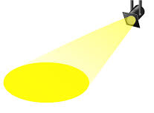
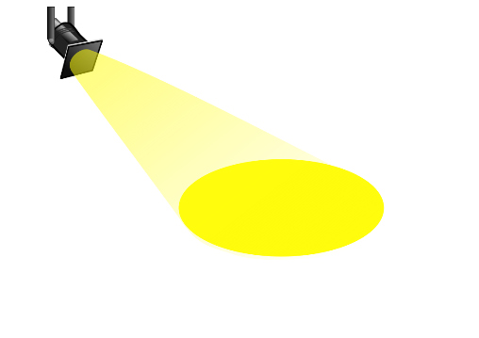
Email your completed application to morgan@fldeca.org
How does your chapter connect with the community and local businesses?
What makes your chapter special?
Chapter Spotlight Application

